**pyspark Assignment1**

**Task 3:**

**Order Data analysis (Joins)**

hdfs dfs -put order_items.csv

hdfs dfs -put orders.csv

hdfs dfs -put products.csv

hdfs dfs -ls

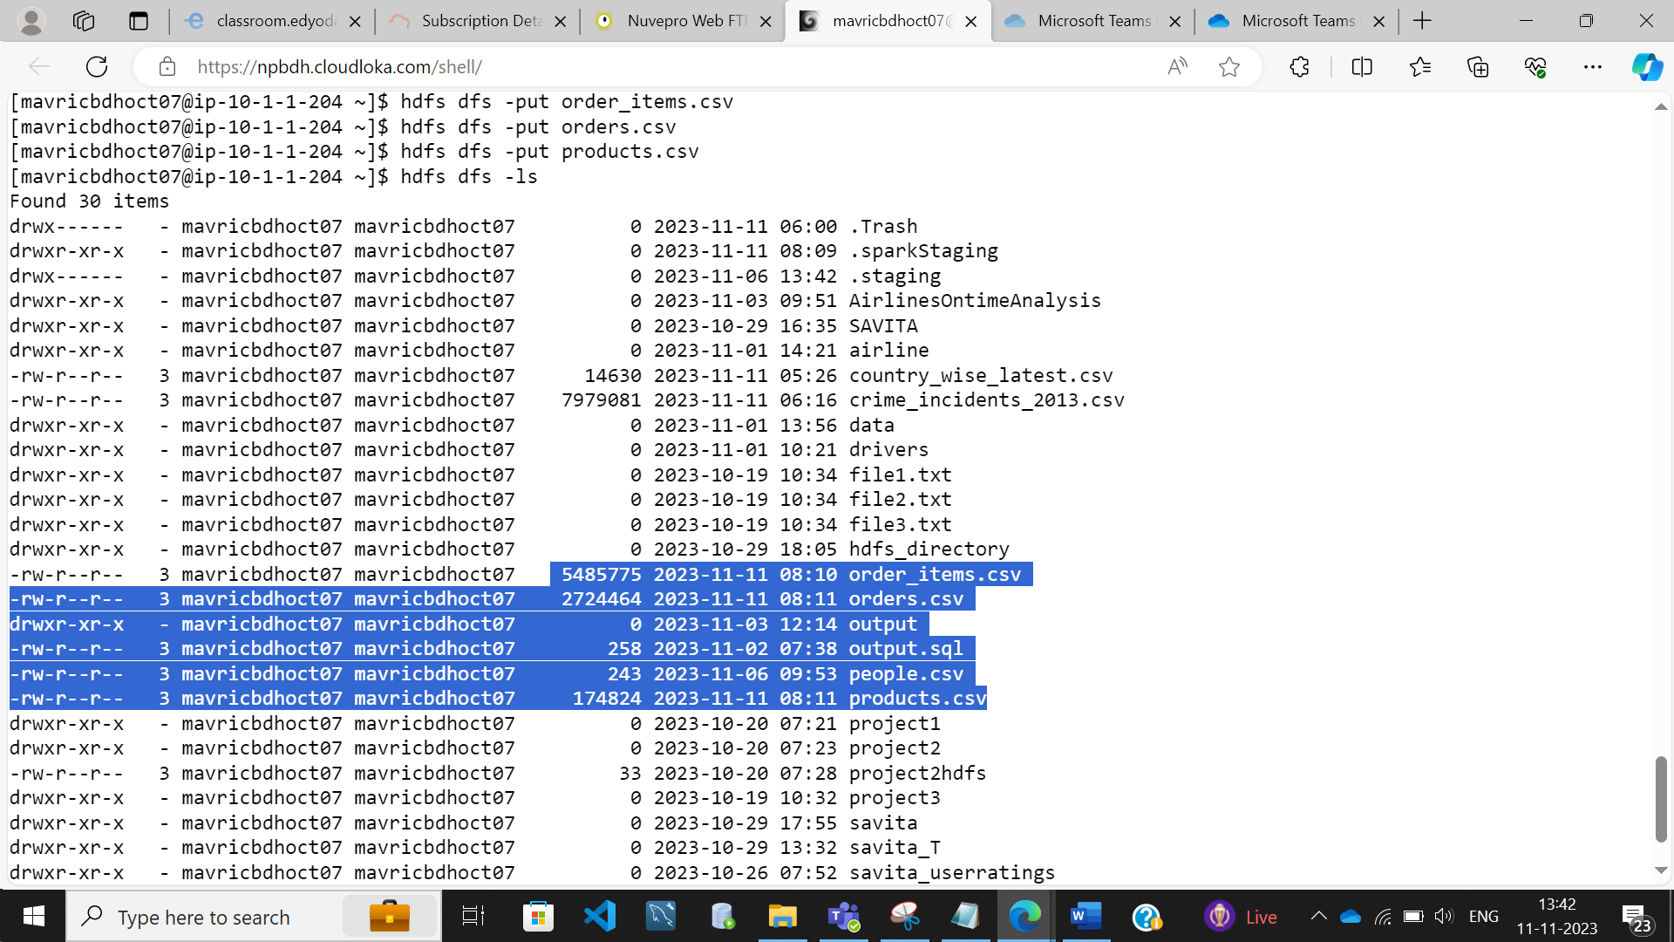

**Products**

productsDF=spark.read.option("header",True).option("inferschema",True).csv("products.csv")

productsDF.createOrReplaceTempView("products")

productsDF.printSchema()

**1. Problem Statement: What is the daily product revenue for CLOSED or**

**COMPLETE orders?**

spark.sql("SELECT order_status,o.order_date, p.product_name ,sum(ot.order_item_subtotal) as revenue from orders o join orderitems ot on o.order_id = ot.order_item_order_id join products p on p.product_id = ot.order_item_product_id where o.order_status in ('CLOSED','COMPLETE') group by order_status,o.order_date, p.product_name").show()

**2. Load the required data in to DF like categories, customer,departments,order_items,orders and products**

**DF1 - Orders_items:**

orderitemsDF=spark.read.option("header",True).option("inferschema",True).csv("order_items.csv")

orderitemsDF.createOrReplaceTempView("orderitems")

orderitemsDF.printSchema()

**DF 2 – orders :**

ordersDF=spark.read.option("header",True).option("inferschema",True).csv("orders.csv")

ordersDF.createOrReplaceTempView("orders")

ordersDF.printSchema()

**DF 3 – products :**

productsDF=spark.read.option("header",True).option("inferschema",True).csv("products.csv")

productsDF.createOrReplaceTempView("products")

productsDF.printSchema()

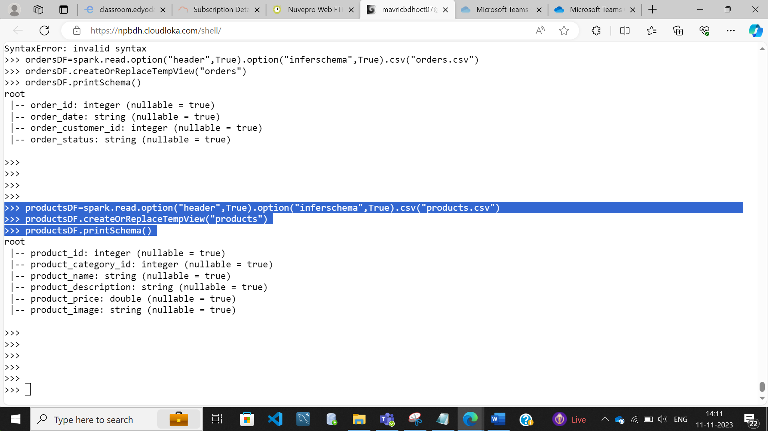

**3. Get the count for each order status**

spark.sql("SELECT order_status, count(order_id) from Orders group by order_status").show()

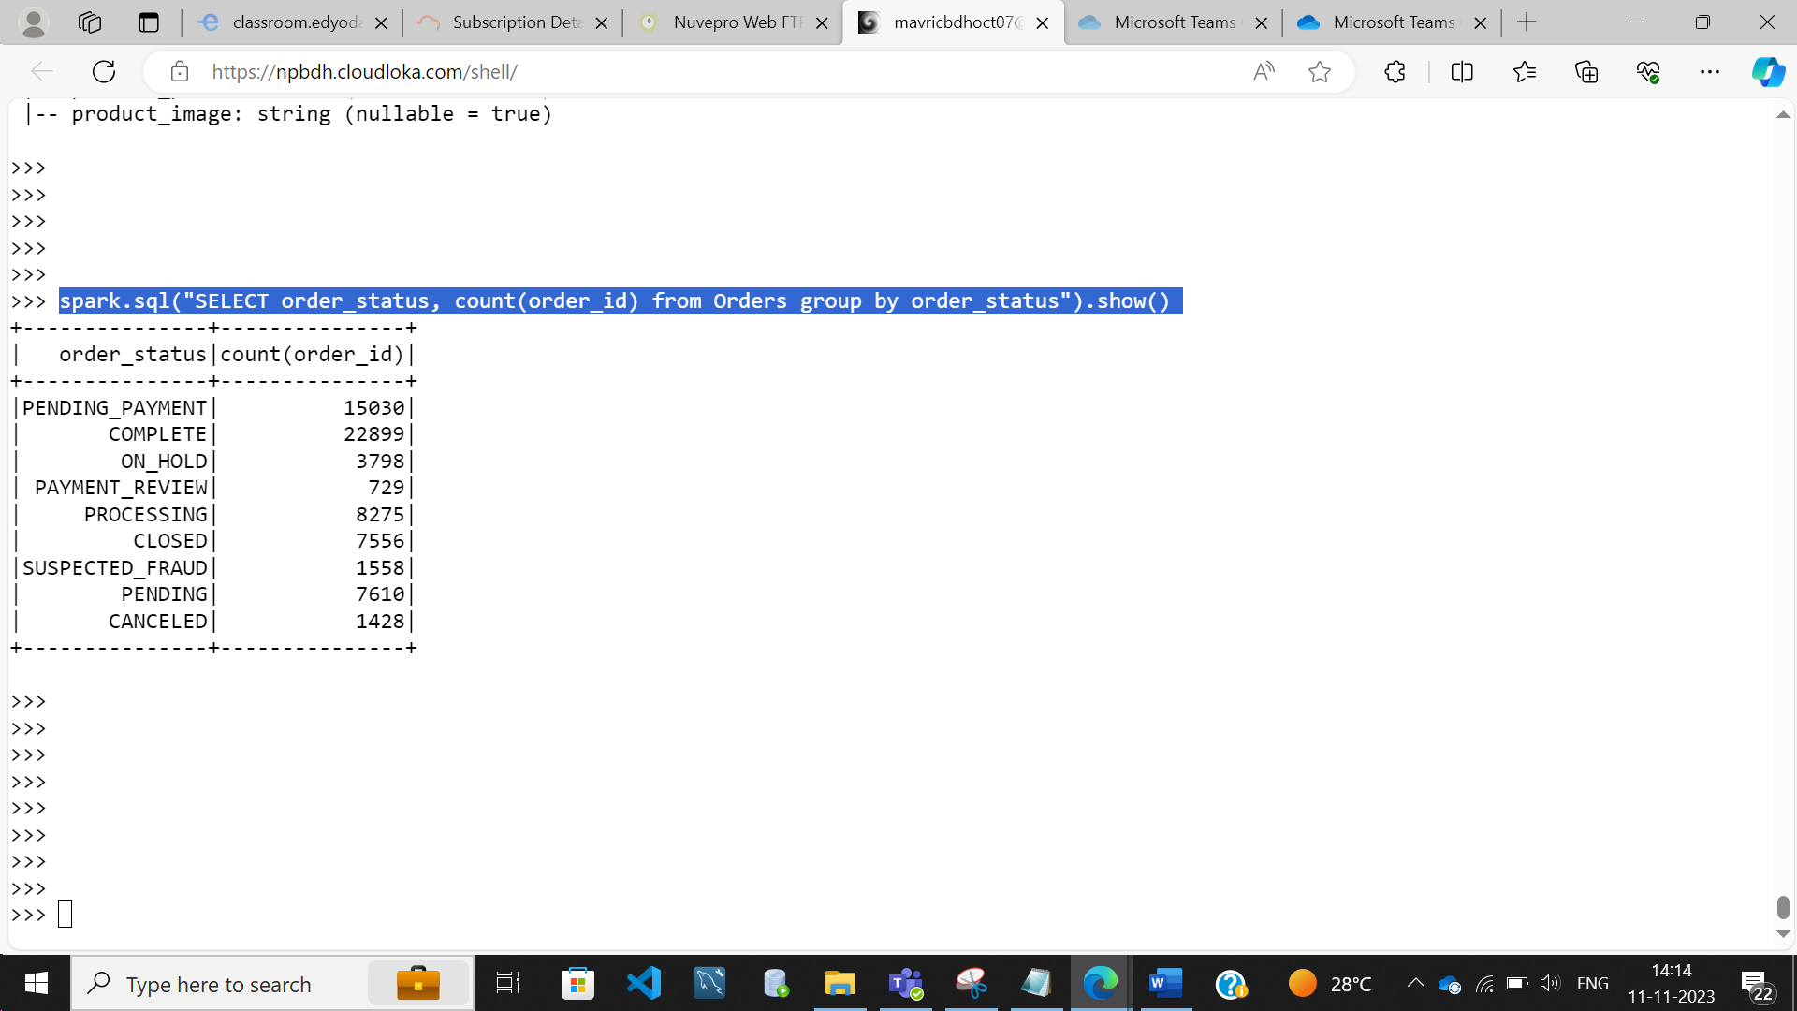

spark.sql("SELECT count(*) from (SELECT o.order_date, p.product_name ,sum(ot.order_item_subtotal) as revenue from orders o join orderitems ot on o.order_id = ot.order_item_order_id join products p on p.product_id = ot.order_item_product_id where o.order_status in ('CLOSED','COMPLETE') group by o.order_date, p.product_name)a").show()

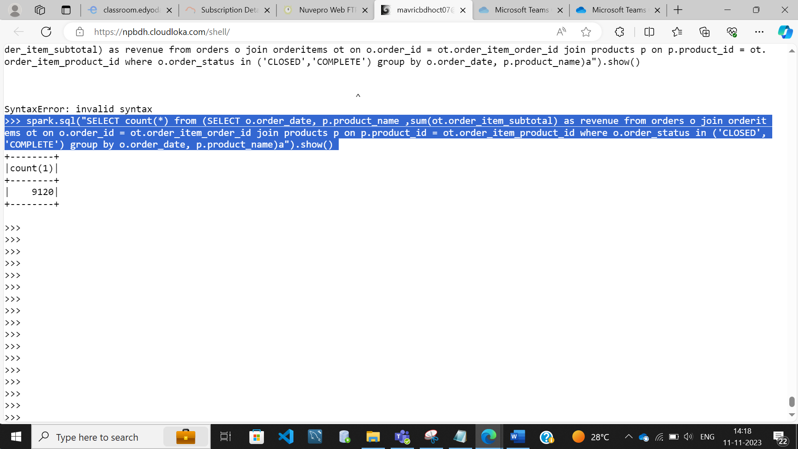

**4. Filter only COMPLETE or CLOSED orders**

ordersDF.filter(ordersDF.order_status == 'CLOSED').show(truncate=False)

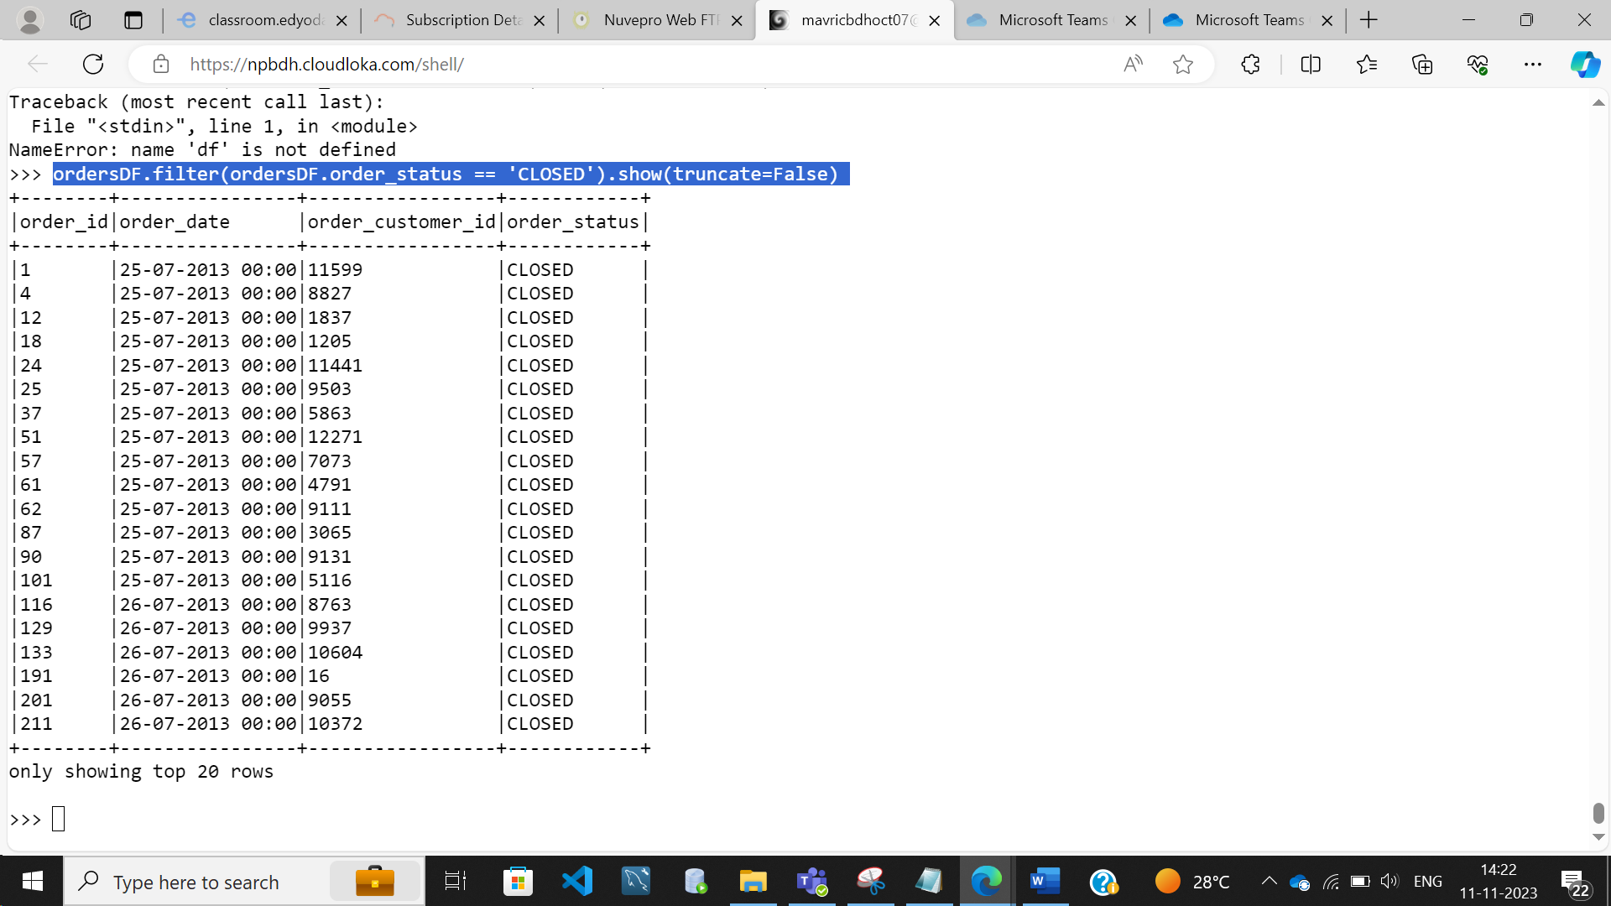

ordersDF.filter(ordersDF.order_status == 'COMPLETE').show(truncate=False)

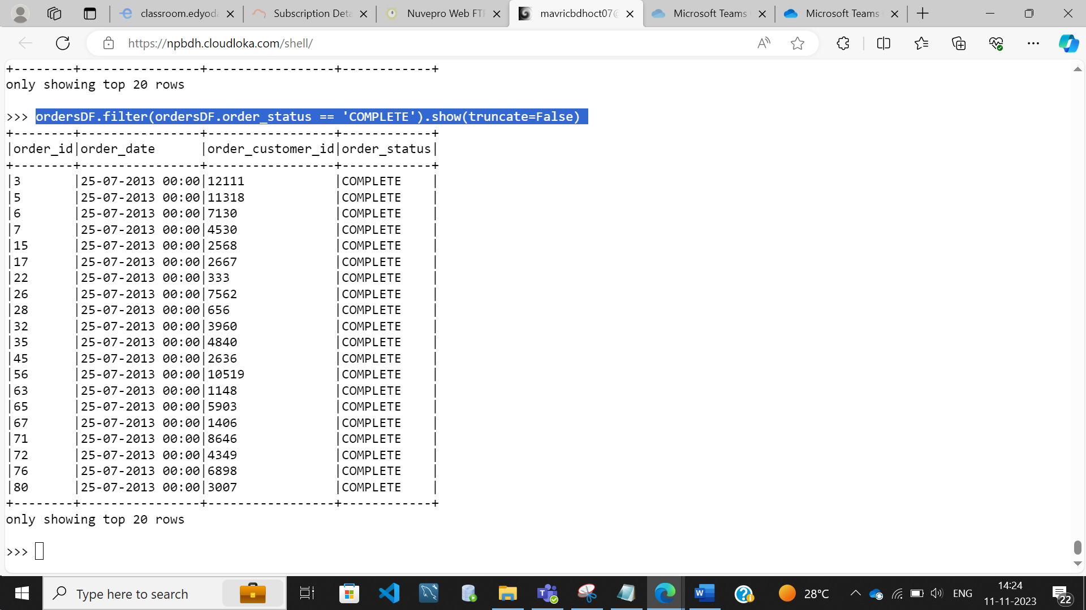

**5. Join the products , order_items and orders tables and calculate daily**

**product revenue**

spark.sql("SELECT o.order_date, p.product_name ,sum(ot.order_item_subtotal) as revenue from orders o join orderitems ot on o.order_id = ot.order_item_order_id join products p on p.product_id = ot.order_item_product_id group by o.order_date, p.product_name").show()

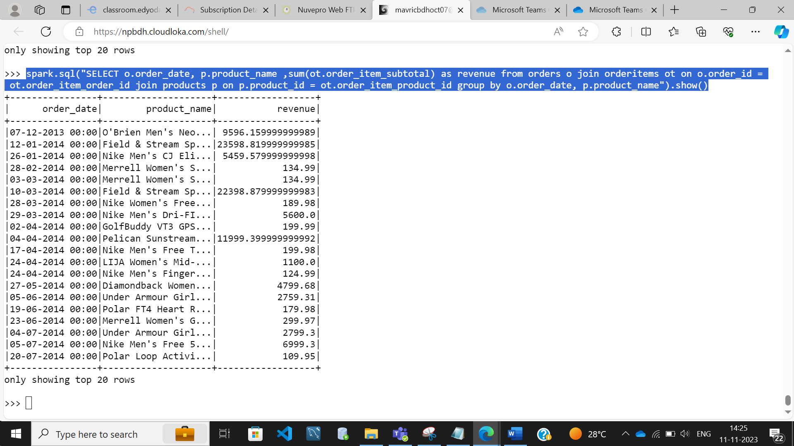

**Count :**

spark.sql("SELECT count(*) from (SELECT o.order_date, p.product_name ,sum(ot.order_item_subtotal) as revenue from orders o join orderitems ot on o.order_id = ot.order_item_order_id join products p on p.product_id = ot.order_item_product_id group by o.order_date, p.product_name)a").show()

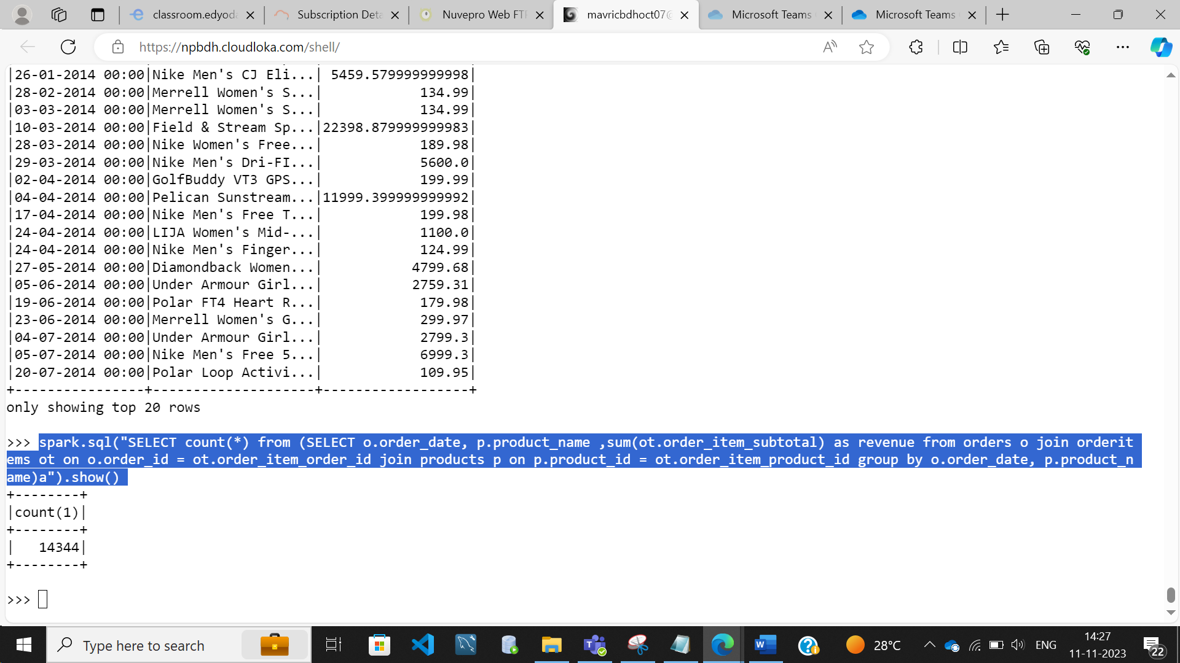

**6. Write the data in to the table Daily product revenue in Hive**

from pyspark.sql import SparkSession

spark=SparkSession.builder.appName("Spark Hive").enableHiveSupport().config("spark.sql.warehouse.dir","/user/hive/warehouse").getOrCreate()

spark.sparkContext.setLogLevel("ERROR")

df = spark.sql("SELECT o.order_date, p.product_name ,sum(ot.order_item_subtotal) as revenue from orders o join orderitems ot on o.order_id = ot.order_item_order_id join products p on p.product_id = ot.order_item_product_id group by o.order_date, p.product_name")

df.show()

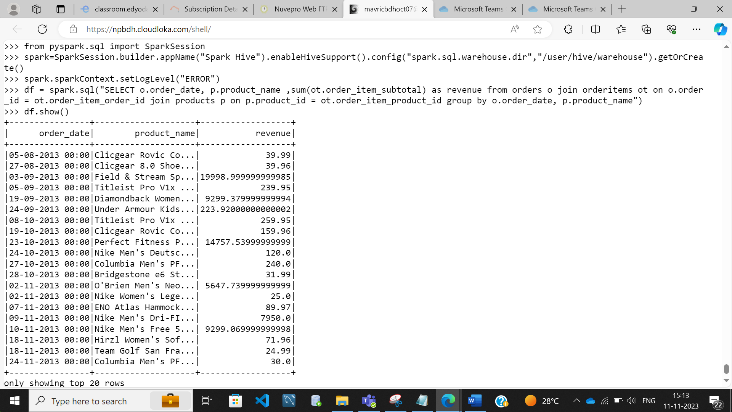

df.write.partitionBy("product_name").mode("overwrite").saveAsTable("indhudb.daily_revenue")

**IN HIVE SHELL:**

**use savitadb;**

**show tables;**

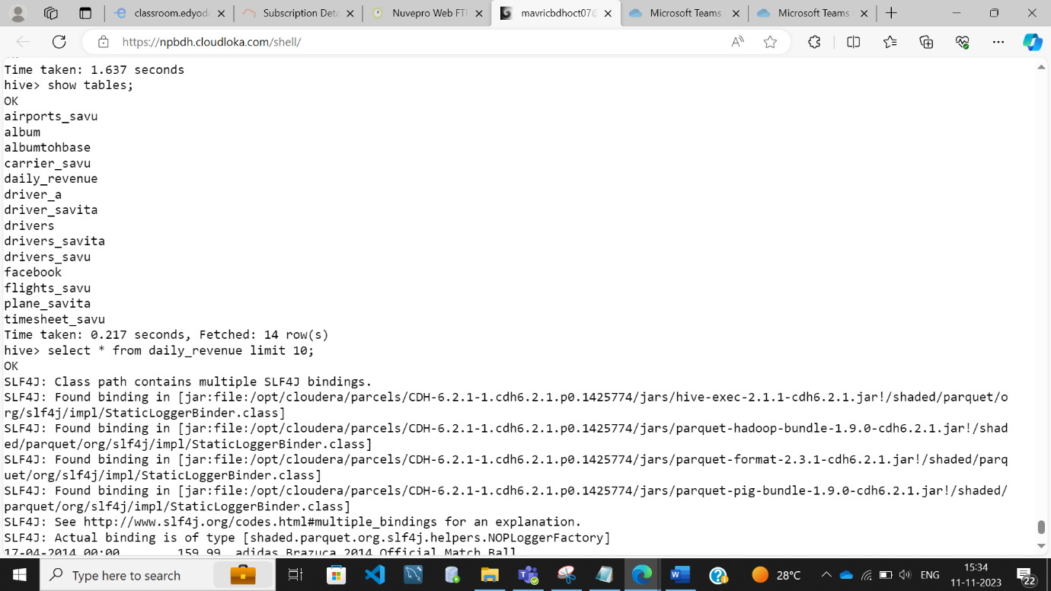

select count(*) from daily_revenue;

**output: 14344**

